

OOP Lab-01 Tasks

Name: Syed Muhammad Raza Ali

Enrolment: 02-134231-028

Course: OOP Lab

Faculty: Miss Hafsa Munawar

**Exercises**

Exercise 1

Create a new java project on NetBeans named as “First_Exercise”. Display a text message saying, “this is my first program”. Provide multiline document string for the created program explaining the process in the program

Code:

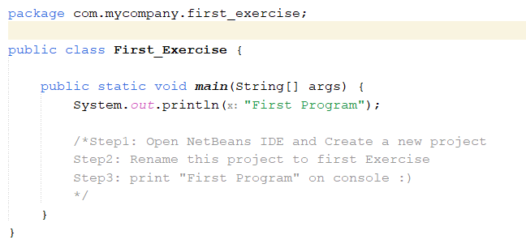

Output:

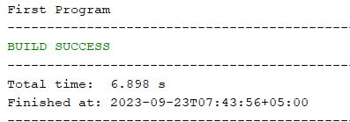

Exercise 2

Create a java program named “Second_Exercise”. Print the name, enrollment, Subject name, Instructor name and semester of a student and attach proper output screen shot. Provide proper comments.

**Code:**

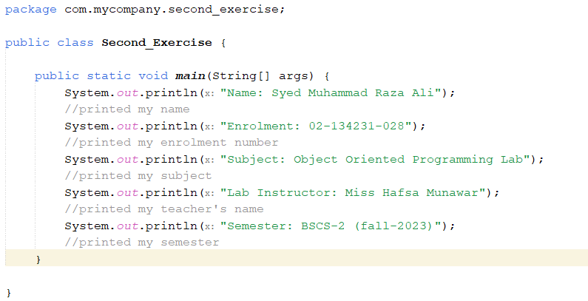

Output:

